Nama : Asri Nihal Salsabila

NIM : 18090087

Kelas : 5C

1. URL : <http://localhost/web2/index.php/web>
2. Source Code

* application 🡪 controller 🡪 web.php

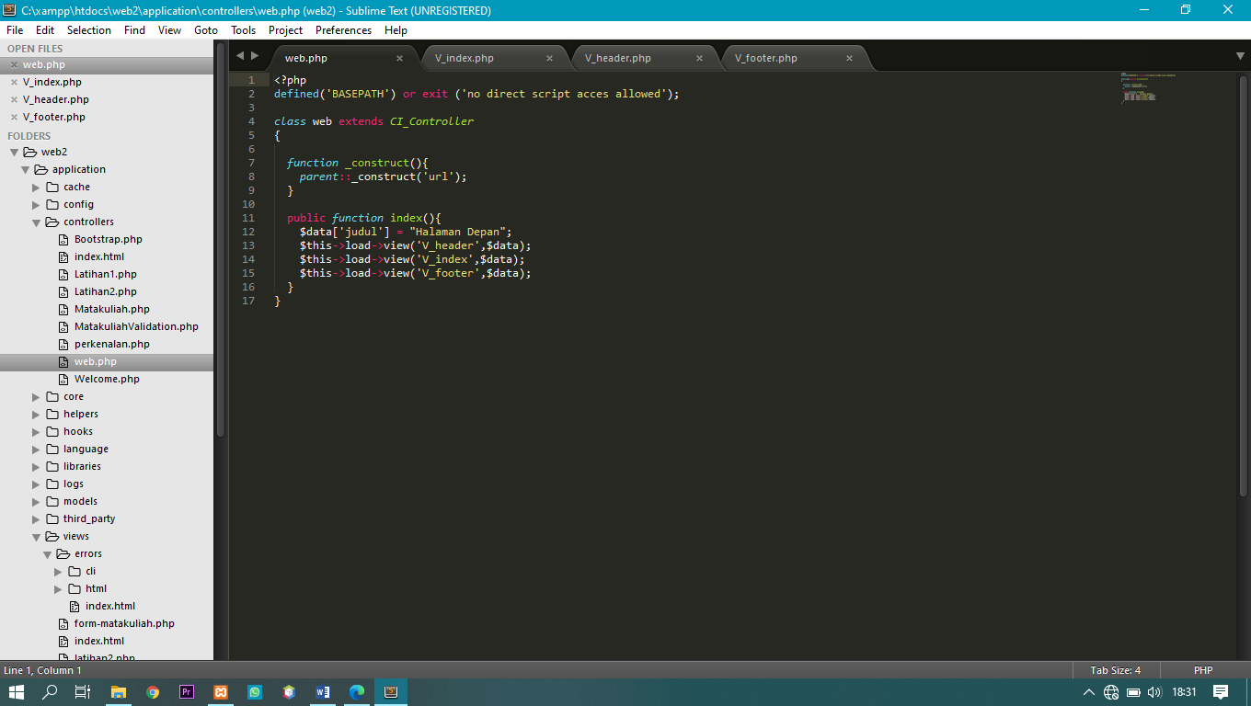

* application 🡪 views 🡪 V_header.php

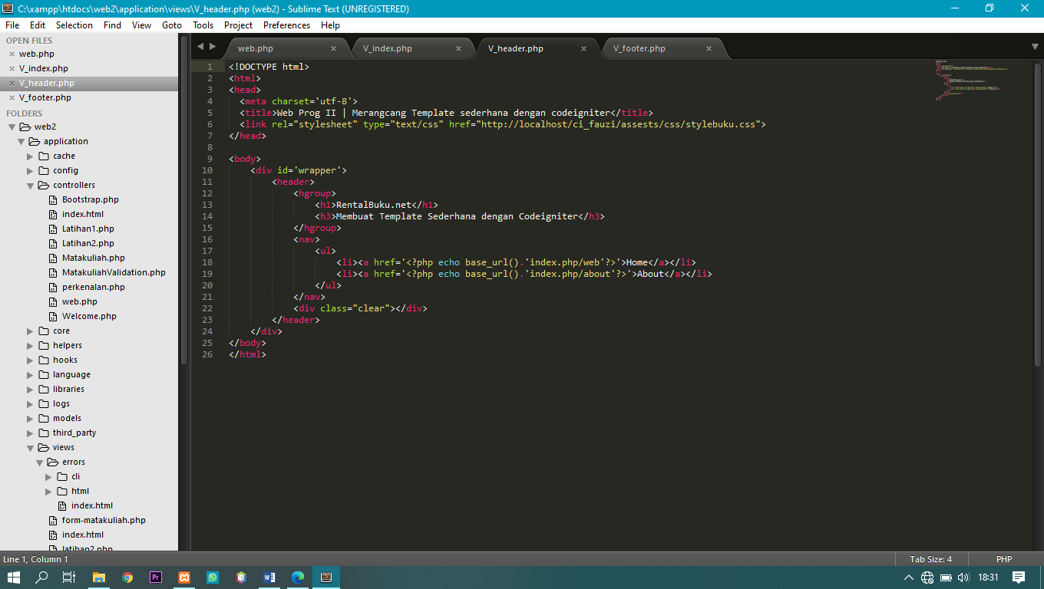

* application 🡪 views 🡪 V_index.php

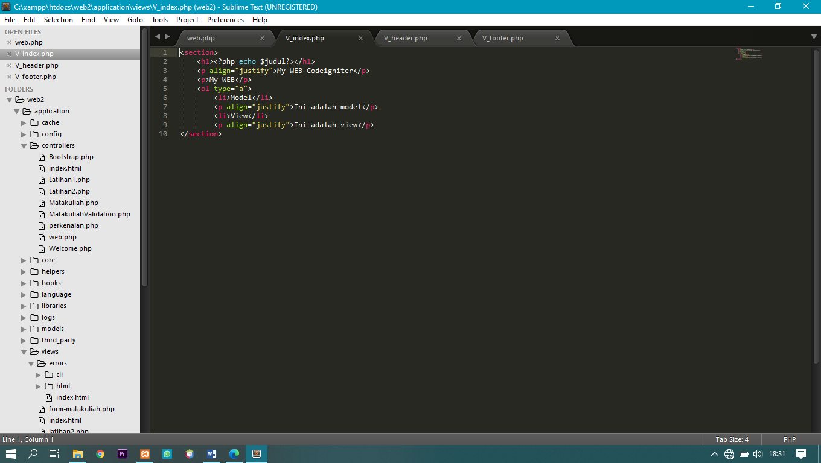

* application 🡪 views 🡪 V_footer.php

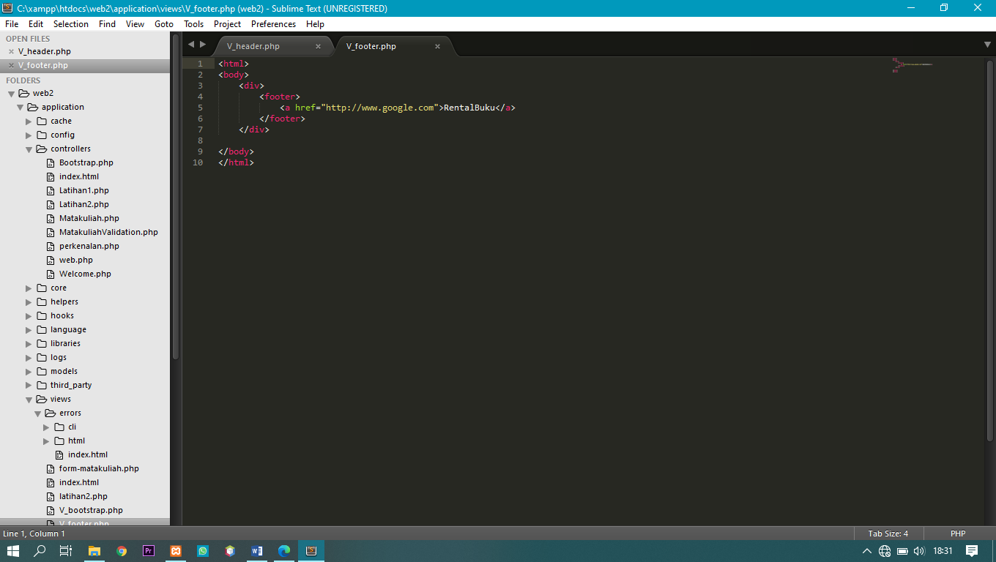

1. Screen Shoot

